Contents

Confidential interval: 1

One sample mean: 2

Here we have 2 scenarios. 2

One sample Variance: 2

One sample proportion: 3

Two sample mean: 3

Two sample mean example: 4

# Confidential interval:

* Just keep in mind we are trying to estimate population proportion(The range of values where the parameter of the population lies) where looking towards the sample proportion. we are surveying a sample, we can get the idea of the proportion from that based upon that we are coming out for the population proportion.
* For estimating the population parameter instead of coming out one single value.

We give one range interval and say we are this much amount confidence that the

Population parameter value falls into this range.

* It’s a contradictory of point estimation where we come out with one estimated

value from the sample which we refer to the population.

# One sample mean:

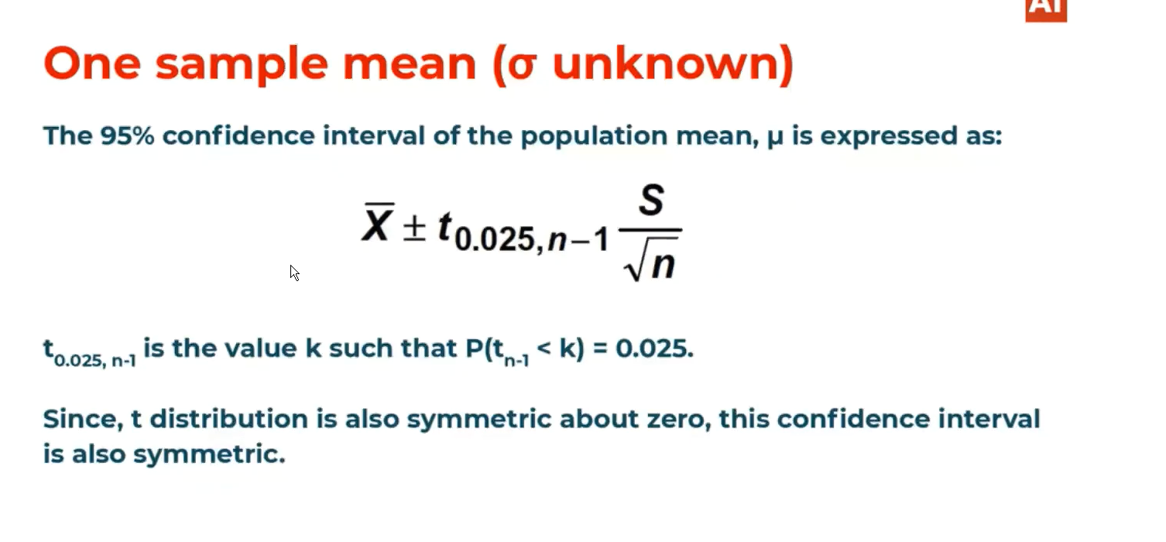

## Here we have 2 scenarios.

* Scenario 1: Sigma is known will just use normal distribution to estimate the population parameter.
* It means to find sample mean we can follow the normal distribution.
* Scenario 2: Sigma (population sd) is unknown and the sample size is very small here we use t-distribution.

# One sample Variance:

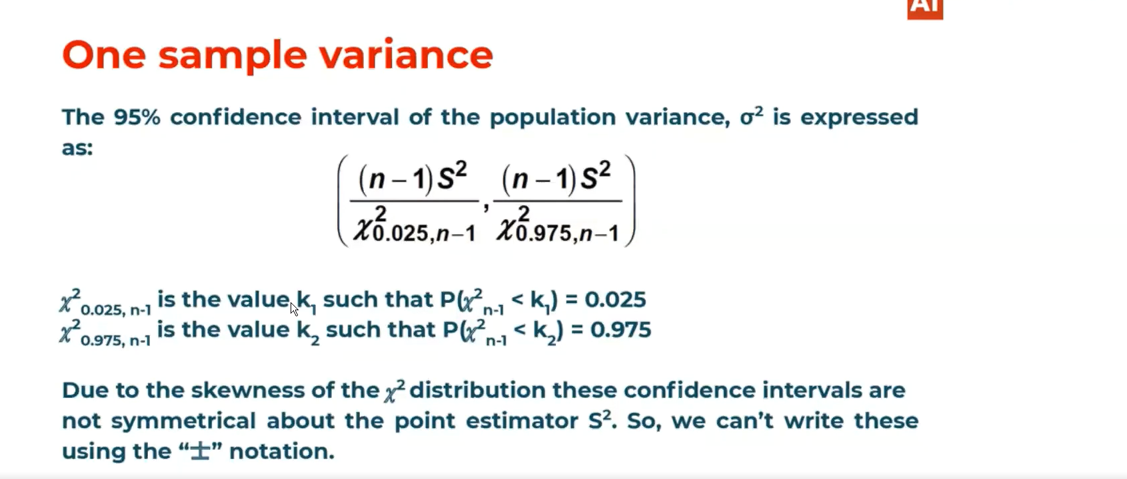

* Its one of the statistics where let’s assume the population confirms to be normal distribution
* Then sample variance could be chi-square distributed with some degree of freedom.
* The chi-square is not symmetric.

# One sample proportion:

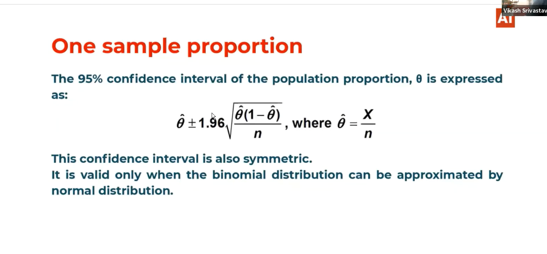

# Two sample mean:

In one Sample mean we can calculate the mean of that sample by surveying it and can estimate the population mean in this particular statistics.

* Consider we need to calculate the population difference.
  + i.e meu1-meu2
* We are consider
* For this we need to take one sample from population 1 and one sample from population 2 and the difference between them is considered to be xbar1-xbar2.
* From this we can estimate meu1-meu2

# Two sample mean example:

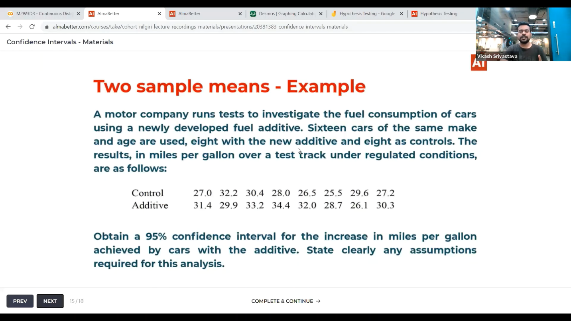

A/B testing:

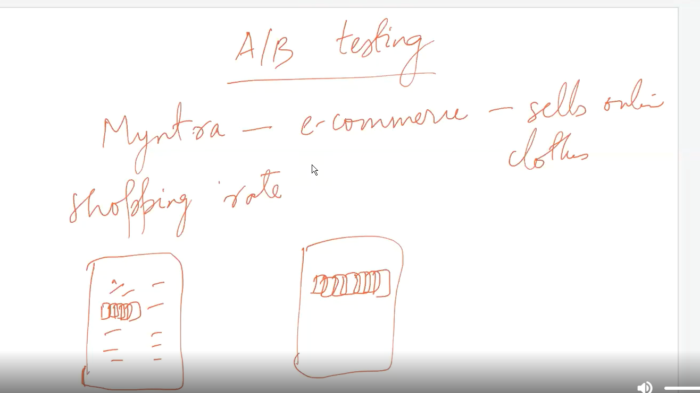

* Take one example as a Product manager at myntra you need to increase the sales rate for that you need to check one thing.
* You decided to increase the number of pictures for each product displayed and in this case we cant release the app with new features directly.
* We need to make 2 groups one for testing and one for ongoing user. Now the testing group can see more pictures of the products than the ongoing users group.
* Here the statistic is increase in the sales of the product.
* Here we can come up with the interval by saying that the increase in the sales are these much.